Come and join our team!
Director of Research and Operations (and member of CfEY Executive Team and Board)
0.8 - 1.0 role with at least two days a week in London. £58K FTE

We are looking for a new member of our three-person executive team.

We want to hear from people who have a passion for improving young people’s lives.
We foster an inclusive culture at CfEY and are committed to building a diverse team. Therefore, we particularly welcome applications from people from people from Black, Asian and minority ethnic backgrounds, disabled people, neuro-diverse people, and people that have taken non-traditional routes to get where they are today.

About us

The Centre for Education and Youth (CfEY) is a ‘think and action-tank’. Our vision is of a society that ensures all children and young people receive the support they need to have a great childhood and make a fulfilling transition to adulthood.
CfEY works with a wide range of organisations and people who share this vision, helping them make wise, bold decisions about how best to support young people. We are committed to social justice and are acutely aware of the interaction between power imbalances and inequality. We work with a wide range of clients across corporate, government and third sectors as learning, investigation, action, and communication partners. In doing so, we shape debate, inform policy and change practices, helping to create systems where all young people, but especially those most at risk of poor outcomes and marginalisation, thrive.

Our approach is unique because…
- We occupy the space between education and youth. We share learning across the divide and advocate for the change that cross-sector collaboration can bring. We bridge policy, practice, and academia, and work with a diverse network of organisations and people, including MATs, schools, colleges, universities, government, businesses, youth organisations, and charities.

- We are ‘constructively critical’. We avoid unhelpful cynicism, focus on how things could be better, and are analytical and intellectually rigorous. We always seek pragmatic ways of helping people take action grounded in evidence and experience. We are optimistic about the future and believe in the power of brilliant practitioners to realise the potential of all young people.

- We are grounded, using our front-line experiences as former teachers, teaching assistants and youth workers and our ongoing positive relationships with diverse young people and practitioners to grapple with complexity and understand what’s happening.

- We do not rely on a set catalogue of solutions. Different approaches and strategies are appropriate in different situations and settings. It is our job to have the emotional and intellectual competence to identify what will work where.

- We are a social enterprise. Everything we do is guided by our view of society’s responsibility, as well as being committed to delivering high-quality projects for our clients. We have no political or party allegiances. Income generation and social impact are mutually reinforcing for us.

You can read more about CfEY and our unique position in the sector in the appendices of this advert.

About the job
This is an exciting, rare and challenging opportunity to join our executive team and board at The Centre for Education and Youth. We are looking for someone with the enthusiasm, commitment and skills to lead our exceptional team alongside our CEO and Director of Partnerships.
We are at a very exciting point in our development, having secured our first large core investment. We need a passionate, innovative and committed leader and research expert to lead our team through this growth.
If you read the below and are unsure whether you are the right person, we’d be more than happy to speak with you about the role and your experience as you consider your application, just get in touch.
First and foremost, we are looking for someone who has leadership experience (leading teams, departments and/or projects, though not necessarily at director level yet), a strong grounding in mixed methods research design and delivery and experience building and leading research partnerships, ideally with a focus on children and young people.
Being a research geek is really key - the person that takes up this role will support the whole team to ensure the methods we propose in new projects are robust, appropriate and feasible so you will need expertise and credibility in this regard. You will also have substantial experience of writing funding proposals securing project income from a range of funders, and of leading multi-stranded research and evaluation projects involving staff and external partners.
The operational aspects of the role involve overseeing and supporting the operations team, overseeing our finances alongside the CEO and making strategic decisions about projects, prioritisation and deploying the team’s capacity. To fulfil the operations side of this role you must have a good mind for processes and systems and some financial acumen, but you do not have to have a background in operations. Our excellent operations team will support you and deliver most operational tasks day-to-day.
Currently, we work across a large range of exciting and innovative projects with a diverse set of clients who work across the education and youth sectors. However, in order to support our growth and greater impact we are seeking to build more partnerships, with other research organisations and higher education institutions, and secure funding for larger research projects. The successful candidate for this role will lead our efforts in building partnerships that lead to funding and will design and oversee these research projects, and would ideally bring a relevant network of organisations along with them. You will not be alone in this mission! All of our team members work collaboratively to secure funding for the projects they know will have impact.
CfEY is a wonderful, unique place to work. Our culture is difficult to explain, but easy to feel when you arrive. We take our work seriously; we take ourselves less seriously. Our structures and decision-making are as open and transparent as possible, and we encourage non-hierarchical approaches within our team. We all tend to muck in on all sorts of tasks, regardless of job title. We’re looking for someone who can both support this culture and move it forward, challenging and supporting the rest of the team and making working together fun.

Further details about the role can be found in the role description on the following page.

Some logistics and details
- You can be located anywhere in the United Kingdom. Our office is located in Hackney, London and the team gathers there every other Monday.
- All directors work in the office for at least one day per week, and are in London for at least one other day to participate in meetings or events. (If you have a disability or a need that makes this difficult, don’t let this put you off the role. We are open to making reasonable adjustments and happy to discuss this with you, either now or later in the process)
- Your job will involve some evening networking events, most of which will be in London. We expect this to be a minimum of about twice a month.
- You will be paid £58K (pro rata). We offer an employer contribution pension (following a six-month probation period) and 33 days of holiday per year (including bank holidays which can be taken flexibly, whenever you want!).
- Travel expenses are covered by CfEY so you will not be ‘out of pocket’ should you need to travel from outside London for events, fieldwork and office days.
- The role can be anything between four and five days per week. Our CEO will be working 4 days per week so he can teach, and our current Director of Research and Operations works a 9-day fortnight.
- We would welcome job share applicants, but you will need to apply as a pair, with a single motivation letter and two CVs.

Role description

Provide organisational leadership
- Work on our executive leadership team to develop and drive the strategic direction of the organisation and to nurture and evolve a positive and collaborative culture.
- Support the Chief Executive to make strategic and operational decisions, deputising when necessary, and sharing leadership of team and SLT meetings.
- Represent the Executive on the Board of Directors (initially in a shadowing role).
- Line manage our Head of Research, Head of Operations (and possibly a new Head of Participation and Programmes) to develop and deliver their respective strand strategies, reporting to the board as required.
- Lead on prioritising and organising opportunities for staff development relating to research and operations.
- Work collaboratively as part of the senior leadership team with all ‘Heads of’ team leaders and the exec team.

Provide Research Leadership
- Direct our approach to conducting research and development projects:
  - Support the generation of ideas within the team and develop your own ideas,
  - Build relationships with partners, funders and other stakeholders,
  - Create and implement a strategy for developing the team’s research skills and expertise
  - work to ensure that we carry out cutting edge, robust methodologies that support our clients’ needs.
- Contribute to our income generation and long-term business growth: bringing in clients; securing grants and contracts, and supporting all team members to contribute fully to our income generation efforts.
- Build new relationships with HEIs and other research organisations to help bring in new, large research projects.
- Oversee and lead a range of projects including evaluation and learning projects, investigative research on key issues affecting education and youth, policy investigations and the development of new innovations with partners.

Provide Operational Leadership
- Oversee our operations including: our financial processes (tracking cashflow, expenditure and building and reviewing our budget), our HR processes and our operational systems.
- Oversee the operational side of our projects, ensuring that quality assurance processes are in place and that they are on time and within budget.
- Support the Head of Operations to develop and execute our operations strategy aiming to slicken and improve the way we do things and ensure that we meet all our organisational legal and HR requirements.

Provide thought leadership
- Maintain an active public profile and be a figurehead for the organisation.
- Build expertise and relationships with partners across a wide range of education and youth issues.
- Secure coverage including mainstream and alternative press and through our own blog, social media and speaking at events.

Take the following approach
- Rigorous
- Flexible approach to time
- Bridging: linking people and organisations and sharing information and ideas
- Professional not pretentious
- Critical but constructive and collaborative
- Understanding client needs and focusing on solutions
- Driven by CfEY vision and projecting a consistent image

About you
We get that life is complicated. If you've taken an unusual, less travelled path to get to where you are now we are interested to hear from you! Almost all of our staff are former teachers or youth workers, but as long as you have had some experience working with young people, and love the idea of continuing to engage with them through our work, that’s good enough. Similarly, you don’t need a detailed understanding of England’s education system, (though this would be a strength), as long as you are willing to learn quickly about policies, trends and people in the education and youth sectors.

Knowledge and experience
Leadership
- You have a minimum of seven years experience in the education, youth charitable or consultancy sectors, and at least two years in a leadership role (not necessarily at Director level)
- You have experience developing and delivering strategic objectives.
- You have experience managing and developing people.

Research
- You have strong expertise in mixed methods research and the ability to share this expertise to guide the team and make strong, credible decisions with regard to approaches and methods.
- You have a wealth of experience in designing, leading and delivering research and development projects with a range of partners. Ideally, these would include some focus on education or youth.

Business development and working with stakeholders
- You have a track record of securing funding: cultivating and sustaining new relationships that generate income.
- You have proven experience in building and developing relationships with a broad range of people and organisations.

Working with children and Young people
- You have some experience, whether in a voluntary or paid, or research or practical capacity, of working with young people.

Skills
Communication
- You are a persuasive communicator who can make a compelling case for change and act as a figurehead for the organisation, building strong relationships across the sector, media and government.
- You write extremely well and adapt your style to suit different audiences.

Operations
- You are an analytical thinker and can identify issues, inefficiencies and gaps in systems and processes and think of solutions to improve them.
- You have some financial acumen and a willingness to learn about business finances

Project Leadership
- You are an exceptionally strong project manager and can oversee multiple projects led by others alongside leading your own set of projects.

Personality and competencies
Vision
- You are 100% committed to and passionate about improving children and young people’s life chances.
- You support our mission and approach. You are determined to build on CfEY’s success.

Leadership and building relationships
- You enjoy leading change and weighing up options and risks, making tough decisions and spotting opportunities even when resources are scarce.
- You have a natural ease with people, you build rapport quickly and have the ability to engage and influence in a collaborative way.
- You lead with humility and kindness as well as high expectations.

Problem solving
- You are pragmatic and can balance the need for practicality and rigour in research and policy.
- You are creative and resilient, with the ability to think laterally, have ideas which you follow through independently, bounce back from challenges and be solutions-focused.
- You are keen to embrace the challenge of working in an
organisation that generates its income by delivering work that meets clients’ needs.

The Process
To support equal opportunities and minimise the risk of bias, we are asking candidates NOT to include their name in their CV, covering letter and file names. Please send your application to Lee-Ann@cfey.org who will pass your documents on to the shortlisting team.
Please note that we are happy to make reasonable adjustments to support disabled or neurodivergent applicants, we will share these throughout the process, should you be selected for interview, but if at any time you would like to make a request or share any details of your needs, please do email abi@cfey.org. Abi will treat your request with confidentiality (if needed) and will work out the best way to ensure our processes work for everyone. Abi will not be involved in sifting applications or sitting on the interview panel.
We are running a rolling application process.
We will a review of applications on Tuesday 26th September and begin to arrange initial interviews with candidates. Applications will stay open beyond this date and we will regularly review applications and conduct interviews on a rolling basis until we find the right candidate.
If you have any questions about this aspect of the process, you can contact Lee-Ann@cfey.org.

1) Initial application: CV and letter
- Please send a maximum two-page CV tailored to this role as well as a maximum 1.5 page letter explaining why you think you are suited to this job and why you'd like to work with us.
- We will conduct a review of applications after the 26th September and will continue to review applications on a rolling basis as needed.
- Your letter doesn’t have to cover every single aspect of the JD or the criteria - your CV might do some of this for you.

2) Interviews
- Interviews will ideally be in our Hackney office, but online is a possibility. If you can’t make this date, please let us know when you apply. This won’t count against you when we shortlist applications.
- This interview stage will be conducted by a panel including our CEO, a non-exec board member and another member of our team.
- We may conduct later interviews as we are running a rolling recruitment process for this role.

3) References and DBS check
- We will inform candidates who have been successful at interview, as soon as possible, before contacting referees.
- Appointments will be confirmed once we have received satisfactory references and DBS check.
- We would ideally like you to start in November, but earlier is fine and later is also possible if a notice period at your current role means you aren’t able to start straight away.
If you have any questions about the role, please contact joe@cfey.org.
Please see further information about The Centre for Education and Youth on the following pages in the appendices.

Appendix 1: More about CfEY
Below you can find further information about who we are, what we do and why and our exciting plans for the next few years. We hope that this gives you more insight into CfEY and why you might want to work with us. We will be happy to answer any questions about this should you be selected for interview.

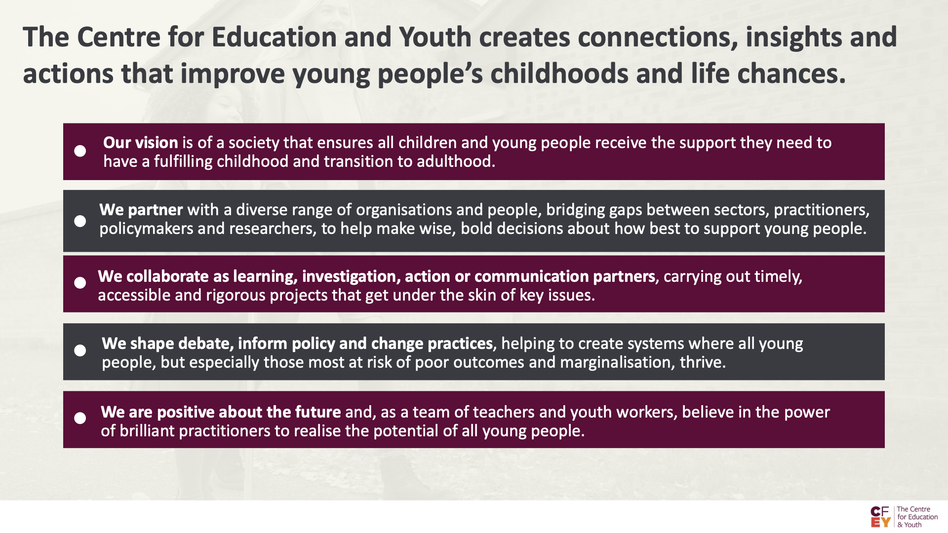
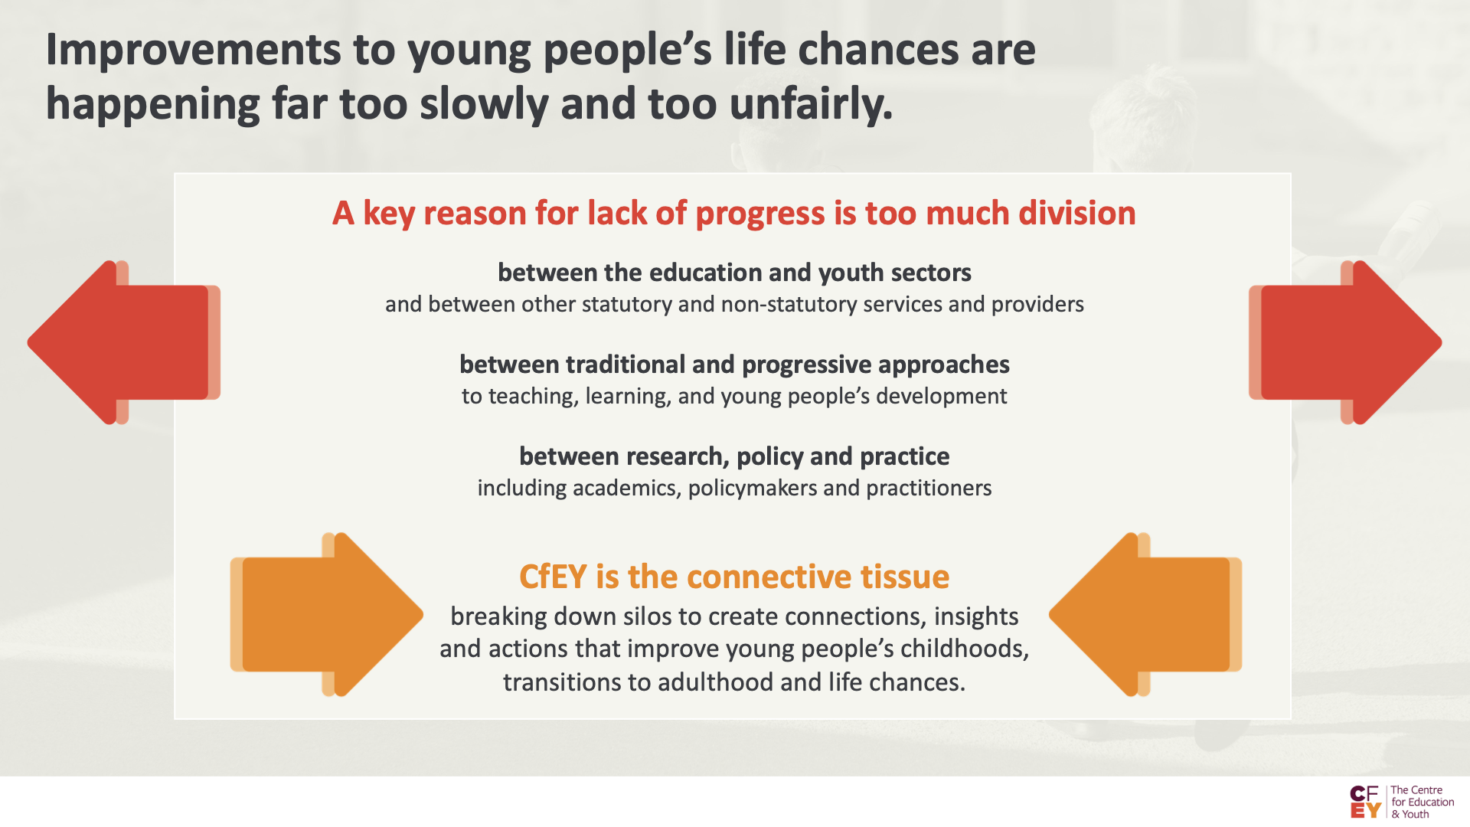
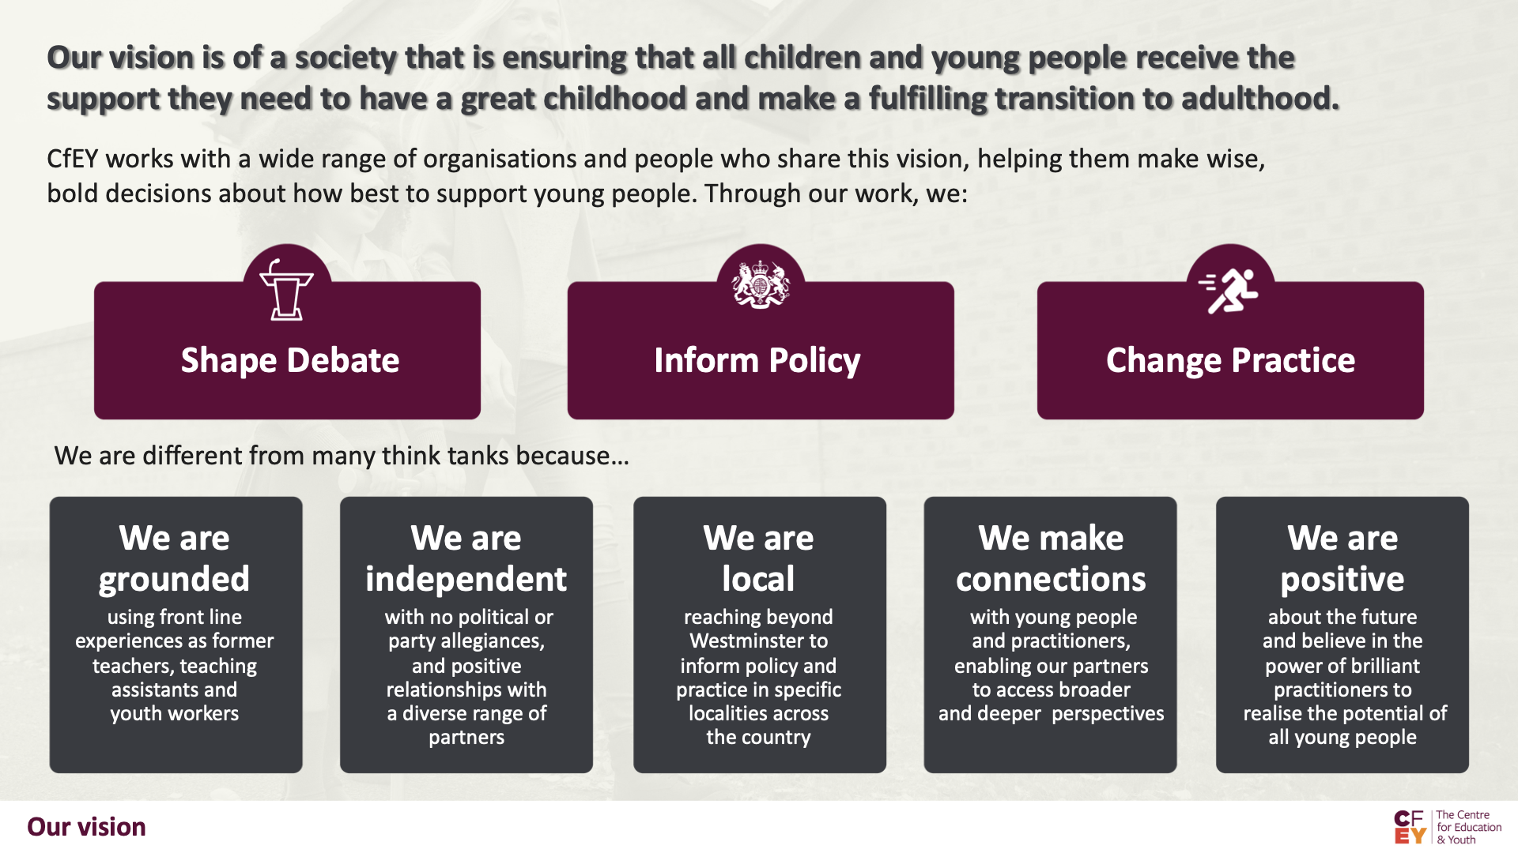

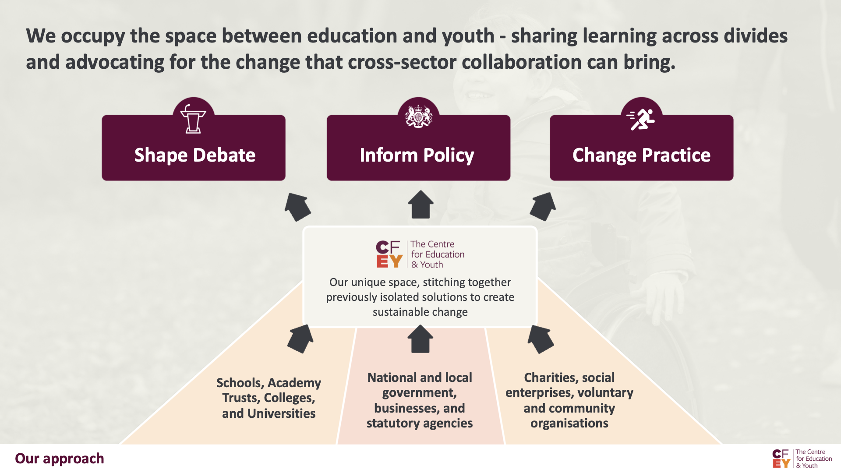

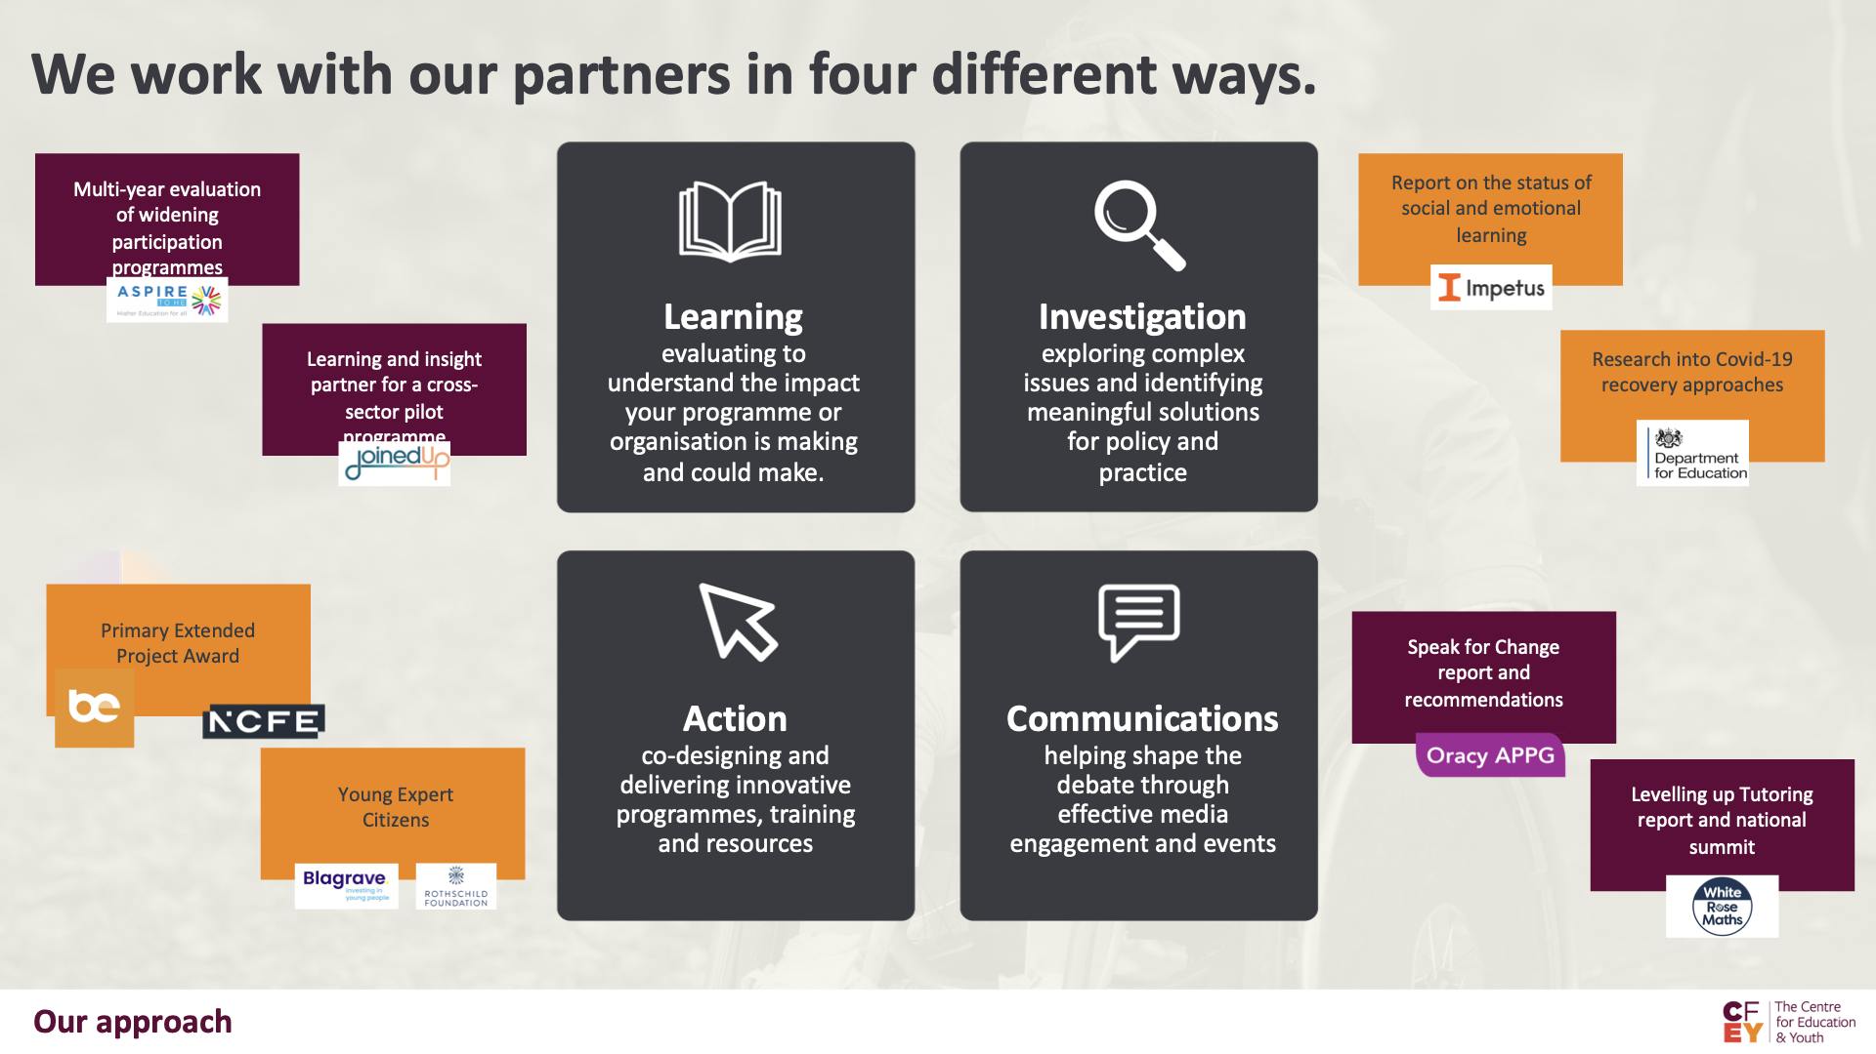

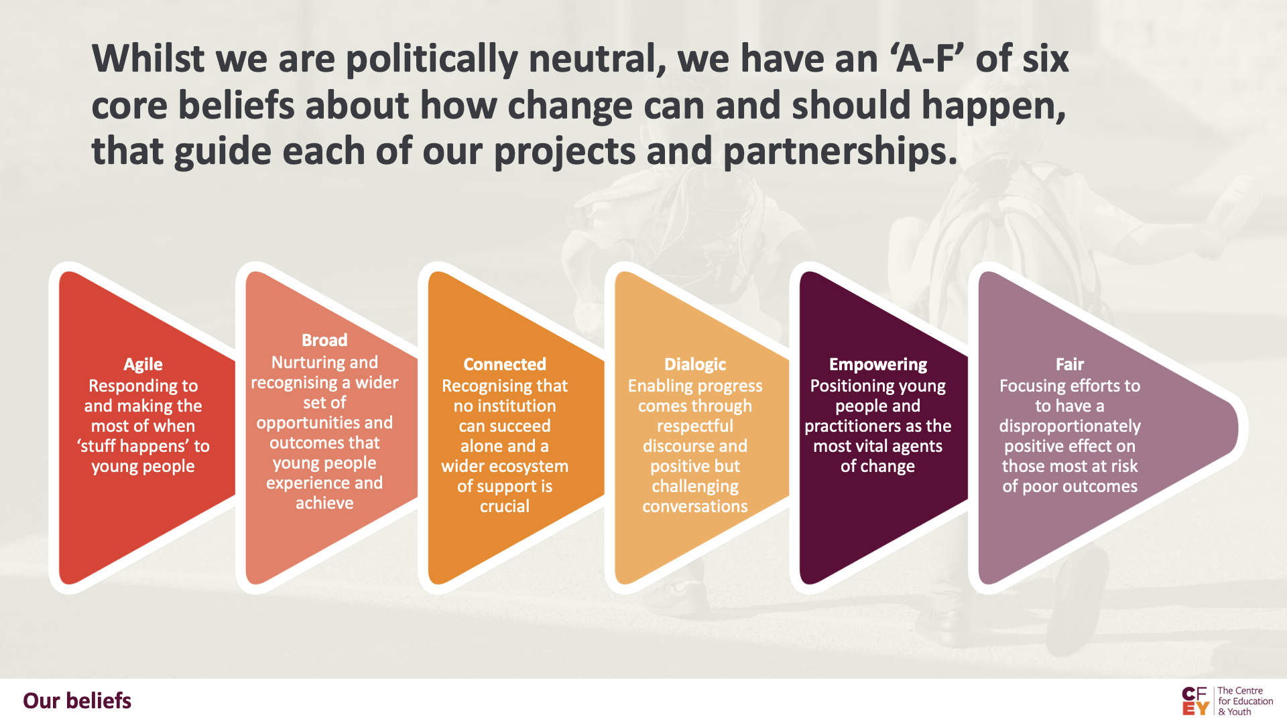

Appendix 2: A brief overview of the guiding principles behind our current strategy

By 2025 we want to achieve a step change in our impact and sustainability, and be seen as indispensable partners for an increasing number of diverse organisations.

THREE STRATEGIC GOALS
In order to achieve even greater impact for young people, CfEY aims to become (even)

- More credible (and opinionated)
Enhancing CfEY’s reputation as a trusted, interesting place for ideas and commentary that always amplifies the views of young people and practitioners.

- More practical (and innovative)
Putting research into action by co-designing and trialling scalable innovations that can have a direct impact on young people and practitioners.

- More proactive (and entrepreneurial)
Shifting the balance of our project portfolio so that a greater proportion of our work is focused on the issues that we believe urgently need attention.

THREE SUPPORTING GOALS
In order to achieve these three goals we will need to change the way we work by becoming (even):

- More productive (and rigorous)
Using our resources more effectively and systematically to achieve greater partner satisfaction and broader impact, within and beyond projects.

- More financially (and organisationally) secure
Evolving and professionalising our income generation approaches and organisational architecture.

- More collaborative (and developmental)
Developing deep, long-term partnerships with a small number of organisations and individuals with whom we can achieve greater impact, and investing time and trust in the leadership potential of all of our staff.

